**Traverse Pages**

**Send Feedback**

Now instead of taking the page as input, you need to traverse between the pages using the buttons.

Initially, when the images are not loaded the two buttons provided to traverse are disabled. When the images are first loaded, one of the button becomes enabled. Going to the next page, makes both the buttons enabled. And the other button becomes disabled when there are no more pages left.

**The web page looks like this -**

[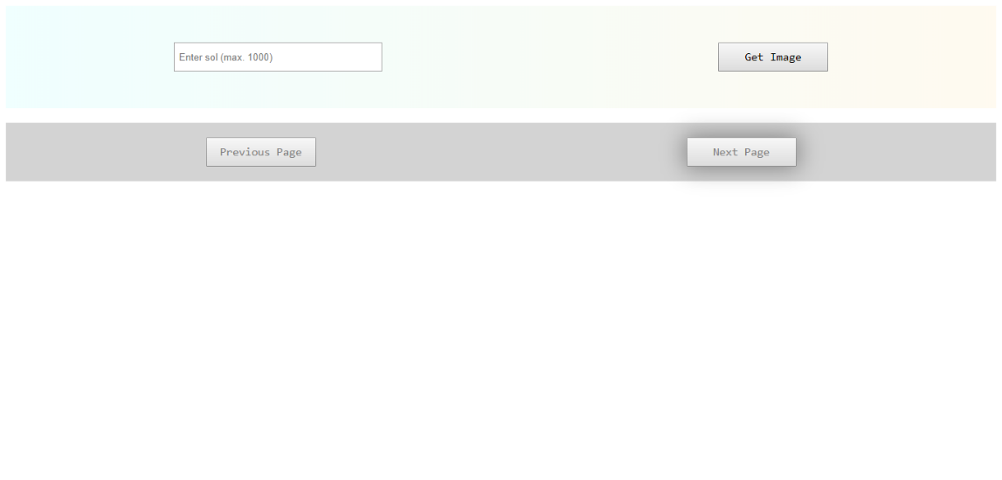](https://ninjasfiles.s3.amazonaws.com/0000000000002048.png)

**After getting the images, the web page would look like this -**

[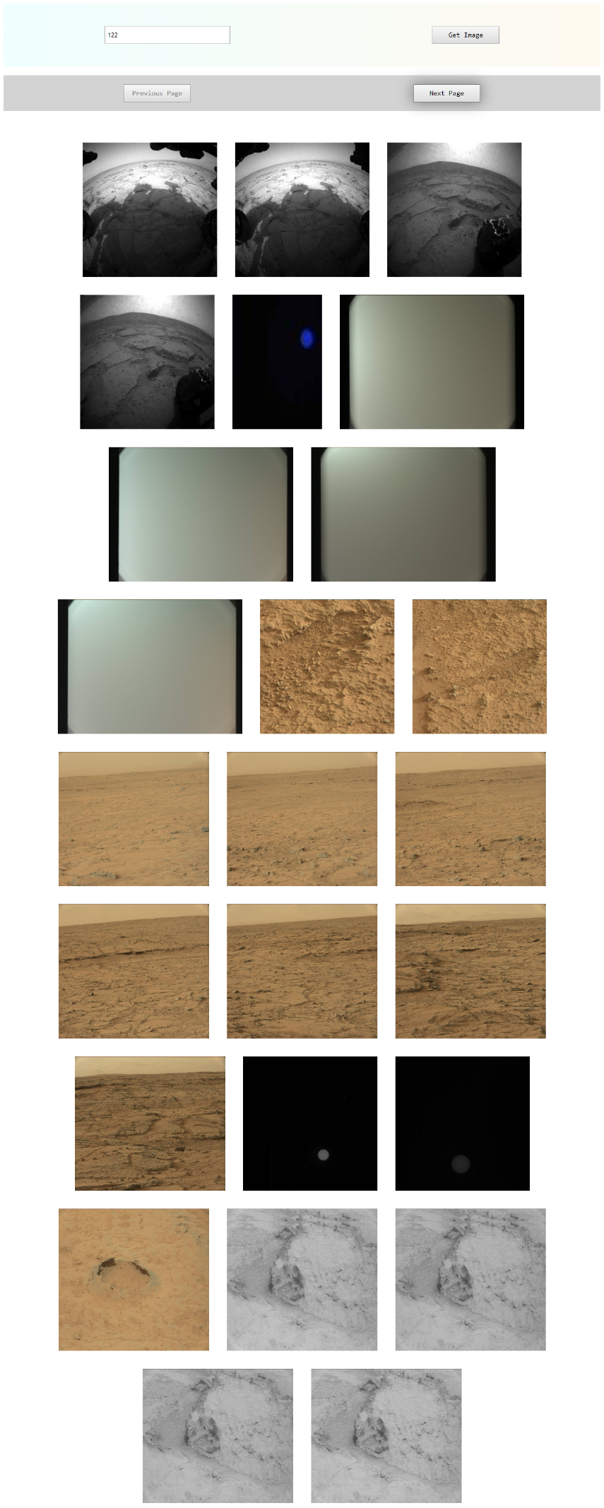](https://ninjasfiles.s3.amazonaws.com/0000000000002049.png)

**On reaching the end of the page, it would look like this -**

[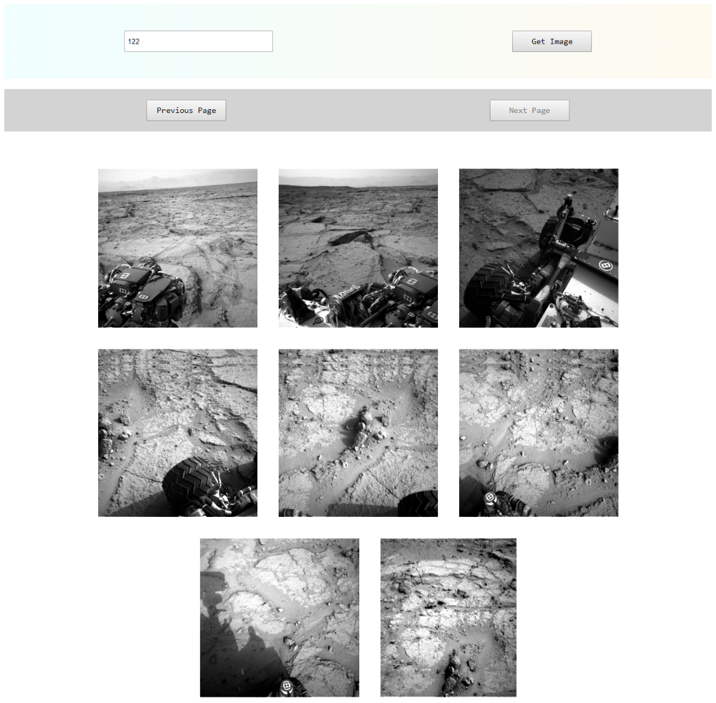](https://ninjasfiles.s3.amazonaws.com/0000000000002050.png)